Lab 4 – Intelligent Pathfinding Using A* and Uniform Cost Search
Student Practical Report
1. Introduction
The problem is modeled as a weighted graph, with each node representing a building on campus, and weights representing the number of travel-time units needed to get from one node to the other. The cost travelled so far and the estimated cost of the remaining path is used for A* while UCS uses only the cost travelled so far. I also adjusted one heuristic value to see how an overestimation of this value can impact the route returned.
2. Objective
The goals for this practical are to:
• Compute and explain g(n), h(n) and f(n) = g(n) + h(n);
• Implement A* with a priority queue;
• Compare A* and UCS with the same graph, start node, and goal node;
• Prove that a heuristic is admissible and consistent;
• Vary a heuristic value and explain the effect of that change on the behavior of the algorithm.
3. Problem Graph and Input Values
The start node is S and the goal node is G. Edge weights are travel-time units. The heuristic values are estimates in the same units.
Directed Edge | Cost
S → A | 1
S → B | 4
A → C | 2
B → G | 5
C → G | 3

Node | S | A | B | C | G
Heuristic h(n) | 5 | 4 | 4 | 2 | 0
True remaining cost | 6 | 5 | 5 | 3 | 0

The two complete routes are S → A → C → G with cost 1 + 2 + 3 = 6, and S → B → G with cost 4 + 5 = 9. Therefore, the optimal route has a total cost of 6.

4. Concepts Used g(n):
Actual path cost from the start node to node n. h(n): Estimated remaining cost from node n to the goal. f(n): A* evaluation value, calculated as g(n) + h(n). Admissible heuristic: A heuristic that never overestimates the true remaining cost. Consistent heuristic: A heuristic satisfying h(u) ≤ cost(u,v) + h(v) for every directed edge u → v.
5. Task 1 – Manual Calculation of g(n), h(n), and f(n)
A* selects the frontier node with the smallest f-value. The following trace uses the supplied successor order and a priority queue ordered by (f, g, node).
Expansion 1: Select and expand S
At the start, g(S) = 0 and h(S) = 5. Therefore, f(S) = 0 + 5 = 5. Expanding S generates A and B:
Frontier node | Calculation | g(n) | h(n) | f(n)
A | 0 + 1; 1 + 4 | 1 | 4 | 5
B | 0 + 4; 4 + 4 | 4 | 4 | 8

A is selected next because f(A) = 5 is smaller than f(B) = 8. Remaining frontier: A(1,4,5), B(4,4,8).
Expansion 2: Select and expand A
For A, g(A) = 1, h(A) = 4, and f(A) = 1 + 4 = 5. Expanding A generates C with g(C) = 1 + 2 = 3 and f(C) = 3 + 2 = 5.

Frontier node | Calculation | g(n) | h(n) | f(n)
C | 1 + 2; 3 + 2 | 3 | 2 | 5
B | 0 + 4; 4 + 4 | 4 | 4 | 8

C is selected next because f(C) = 5 is smaller than f(B) = 8. Remaining frontier: C(3,2,5), B(4,4,8).
Expansion 3: Select and expand C
For C, g(C) = 3, h(C) = 2, and f(C) = 3 + 2 = 5. Expanding C generates G with g(G) = 3 + 3 = 6 and f(G) = 6 + 0 = 6.

Frontier node | Calculation | g(n) | h(n) | f(n)
G | 3+ 3; 6 + 0 | 6 | 0 | 6
B | 0 + 4; 4 + 4 | 4 | 4 | 8

G is selected next because f(G) = 6 is smaller than f(B) = 8. The first three expanded nodes are S, A, and C. The goal G is then processed and the returned route is S → A → C → G with cost 6.
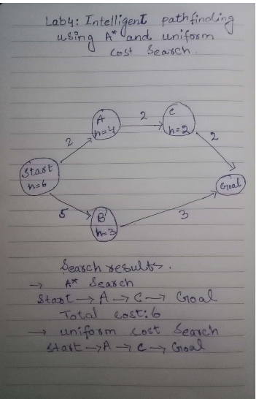

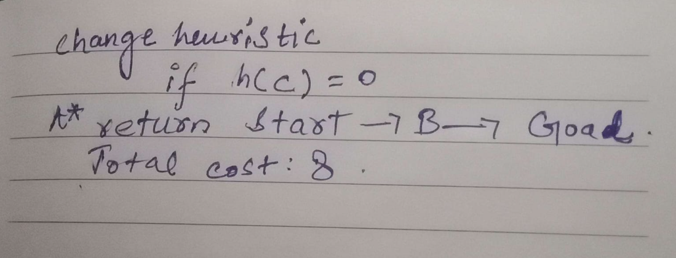

6. Task 2 – A* Search and UCS Comparison
With the same weighted graph, and S as starting node and G as the goal node, both algorithms were performed. All of the heuristic values were set to zero for the UCS control run. Only when successors are considered is a node considered expanded. The goal is not part of the expanded goal count but is part of the processed count. Entries in the queue are discarded if they have not been removed for some time.
7.A* Search with the supplied heuristic
The trace of processed nodes is S, A, C, G, and the number of nodes that have their successors examined is 3. The route that was returned is S → A → C → G, and the cost of the route (summed independently) is 1 + 2 + 3 = 6.
Uniform Cost Search (UCS)
In the case of Uniform Cost Search (UCS) every node has h(n) = 0. The successor of nodes S, A, C, and B are checked, then the expansion count is 4. The sum of independently determined cost of the returned journey is S → A → C → G is 6.

Measure | A* Search | UCS
Heuristic | Supplied values | Zero for every node
Returned path | S → A → C → G | S → A → C → G
Reported path cost | 6 | 6
Independently summed cost | 6 | 6
Processed-node trace | S, A, C, G | S, A, C, B, G
Expanded nodes | 3 | 4

8. Task 3 – Overestimating Heuristic Experiment
Only the heuristic value of node C was changed. Its original value was h(C) = 2, and its modified value was h(C) = 10. The true remaining cost from C to G is 3, so the modified value overestimates the remaining cost and is inadmissible.

Node | Original h(n) | Modified h(n)
S | 5 | 5
A | 4 | 4
B | 4 | 4
C | 2 | 10
G | 0 | 0

After expanding S and A, the frontier contains B with f(B) = 4 + 4 = 8 and C with f(C) = 3 + 10 = 13. B is selected. Expanding B generates G with g(G) = 4 + 5 = 9 and f(G) = 9. Since 9 is less than 13, G is selected before C. The modified run returns S → B → G with cost 4 + 5 = 9. Its processed-node trace is S, A, B, G, and its expansion count is 3.

Measure | Original heuristic | Modified h(C)=10
Returned path | S → A → C → G | S → B → G
Total cost | 6 | 9
Processed trace | S, A, C, G | S, A, B, G
Expanded nodes | 3 | 3

